**MONEY** TRACKER WEBAPP

**Technology for frontend**

* **HTML**
* **CSS**

**Technology for backend**

* **NodeJS**

**Technology for Database**

* **MongoDB**

**Dependence for running the application**

* **Nodemon 3.1.0**
* **ejs 3.1.9**
* **mongoose 8.2.1**
* **Body-parser 3.1.0**

**Landing page**

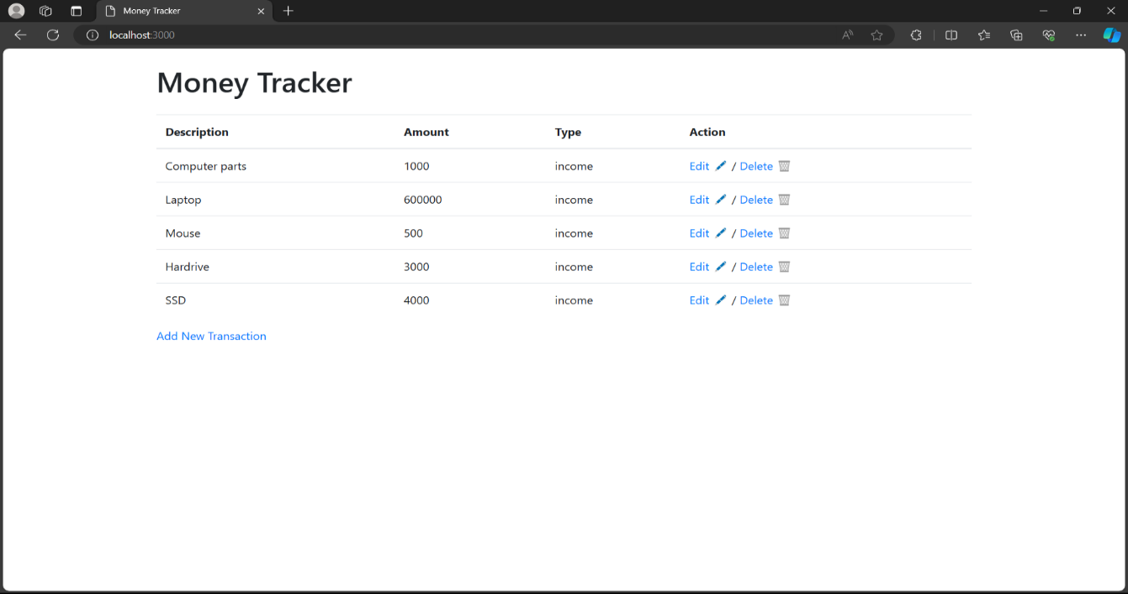

**Add Transaction page**

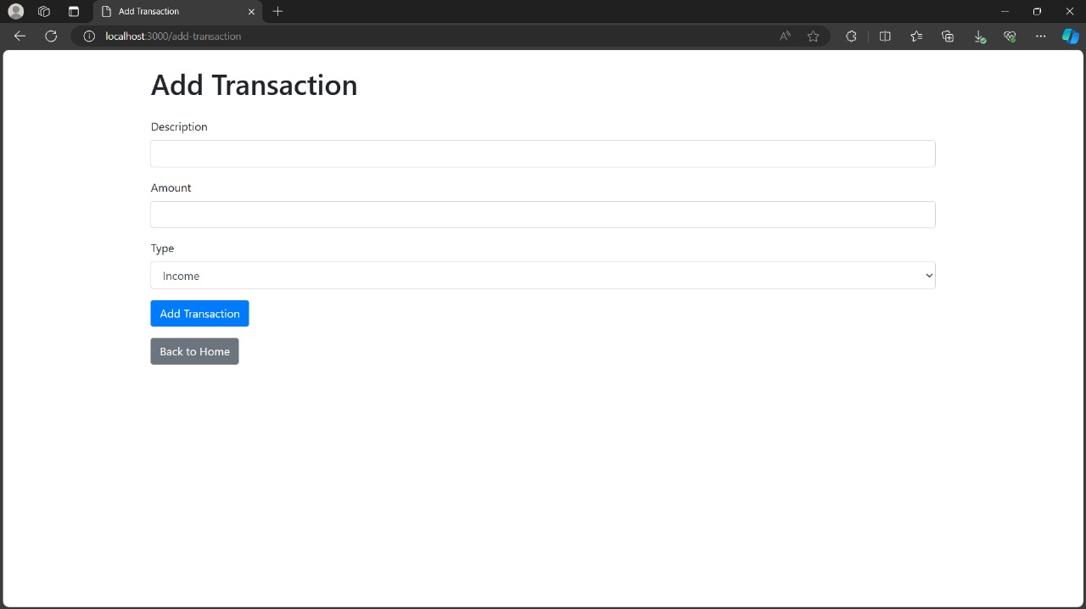

**Edit Transaction page**

